“HOTEL MANAGEMENT SYSTEM”
Name: KHAN SHAGUFTA/KHAN IQRA
Class/Batch: SYIT
Project Title: HOTEL MANAGEMENT SYSTEM USING PYTHON USING GUI

1. Project Description:
Hotel Management System is a Python-based GUI application designed to simplify and automate daily hotel operations. The system provides an easy-to-use graphical interface for managing room bookings, customer details, check-in/check-out, room availability, billing, and payment records. It reduces manual work, improves accuracy, and helps hotel staff manage information efficiently.
This code demonstrates the main functionality of the Hotel Management System using Python Tkinter GUI. It allows users to select a room, enter check-in/check-out dates, calculate the number of days, and automatically generate the total bill based on the room price.

2. Code Snippet:
import tkinter as tk
from tkinter import ttk, messagebox
from datetime import datetime

root = tk.Tk()
root.title("Hotel Management System")
root.geometry("1050x650")

# Room prices
room_prices = {
"101 - Single Room": 1500,
"102 - Single Room": 1500,
"201 - Double Room": 2500,
"301 - Deluxe Room": 3500,
"401 - Suite": 5000
}

def calculate_bill():
try:
checkin = datetime.strptime(checkin_var.get(), "%d-%m-%Y")
checkout = datetime.strptime(checkout_var.get(), "%d-%m-%Y")

if checkout <= checkin:
messagebox.showerror("Error",
"Check-out must be after check-in")
return

days = (checkout - checkin).days
price = room_prices[room_var.get()]
total = days * price

days_var.set(str(days))
amount_var.set(f"Rs. {total}")

except ValueError:
messagebox.showerror(
"Error", "Enter date in DD-MM-YYYY format"
)

# GUI variables
name_var = tk.StringVar()
phone_var = tk.StringVar()
room_var = tk.StringVar()
checkin_var = tk.StringVar()
checkout_var = tk.StringVar()
days_var = tk.StringVar()
amount_var = tk.StringVar()

# Room selection
room_box = ttk.Combobox(
root,
textvariable=room_var,
values=list(room_prices.keys()),
state="readonly"
)
room_box.pack(pady=10)

# Calculate bill button
tk.Button(
root,
text="Calculate Bill",
command=calculate_bill
).pack(pady=10)

root.mainloop()

3. Output Screenshot:
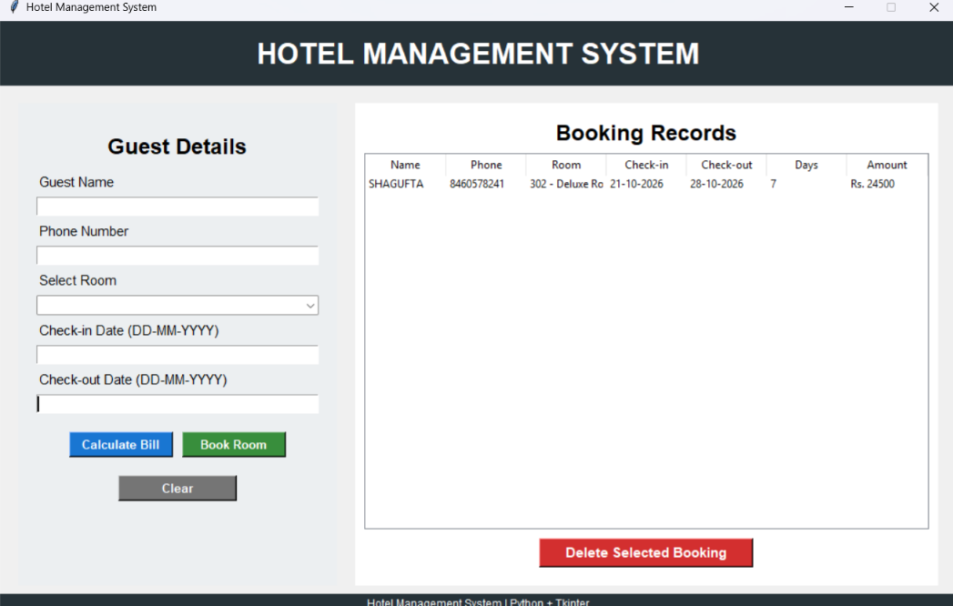

6. Additional Notes:

Challenges Faced
- Designing a user-friendly GUI using Tkinter.
- Validating check-in and check-out dates correctly.
- Calculating the total bill based on room price and number of days.
- Preventing duplicate room bookings.
- Managing booking records using the Treeview widget.
- Handling invalid or missing user inputs using error messages.

Future Improvements
- Add a database such as MySQL or SQLite to permanently store bookings.
- Add login and user authentication for hotel staff.
- Add online payment and invoice generation.
- Add automatic room availability/status management.
- Add customer search, update, and booking history features.
- Improve the GUI with modern themes, icons, and better navigation.

Learning Outcomes
- Learned how to develop a GUI application using Python Tkinter.
- Understood event-driven programming and functions.
- Learned input validation and error handling.
- Gained experience with date calculations and billing logic.
- Learned how to display and manage records using Tkinter's Treeview.
- Improved problem-solving, debugging, and Python programming skills.

